Burning CDs in Inteleviewer
- Login to Inteleviewer and enter the patient Last Name, First Name in the PATIENT NAME section and hit SEARCH:
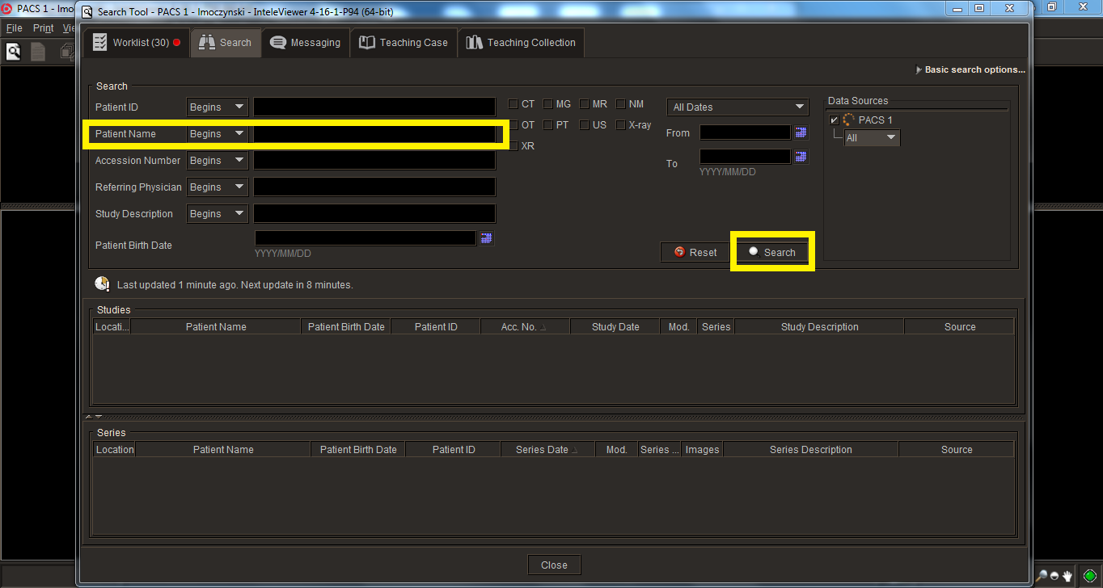
- A list of the patient exams will pop up. RIGHT CLICK on the exam and hit BURN TO CD/DVD:
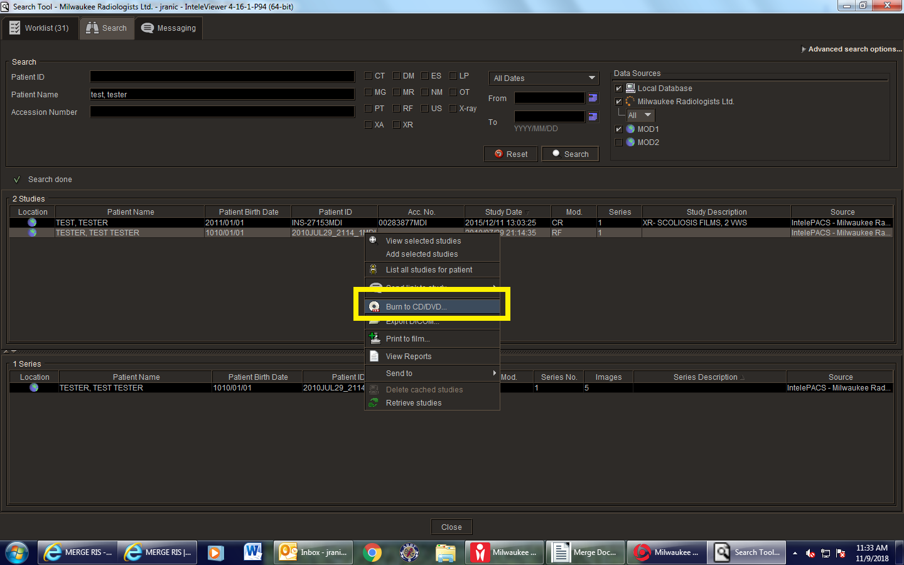
- You can include the report on the disc but this is not necessary, then click BURN:
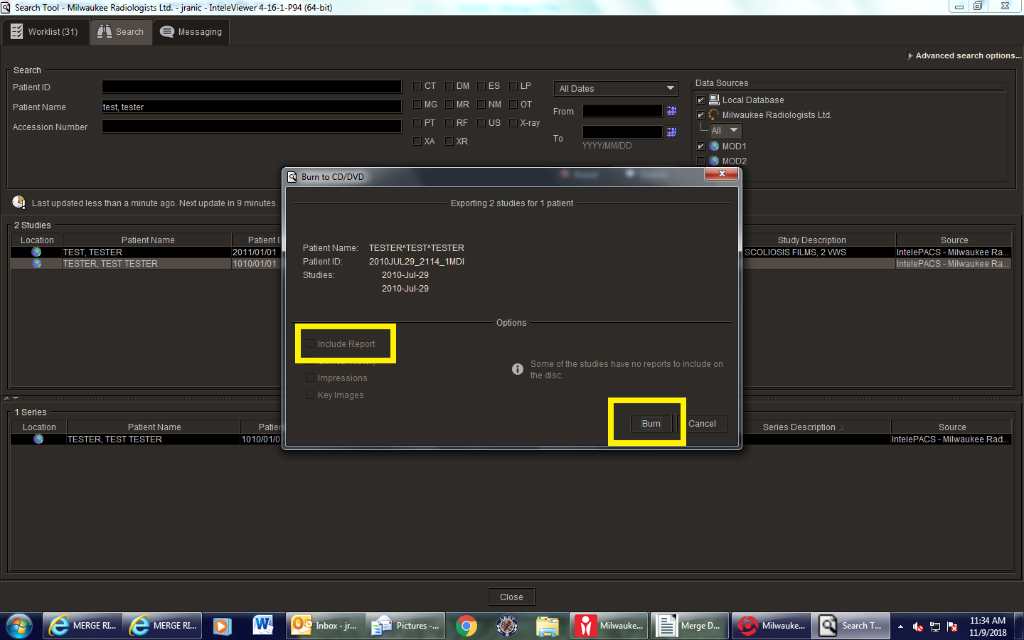
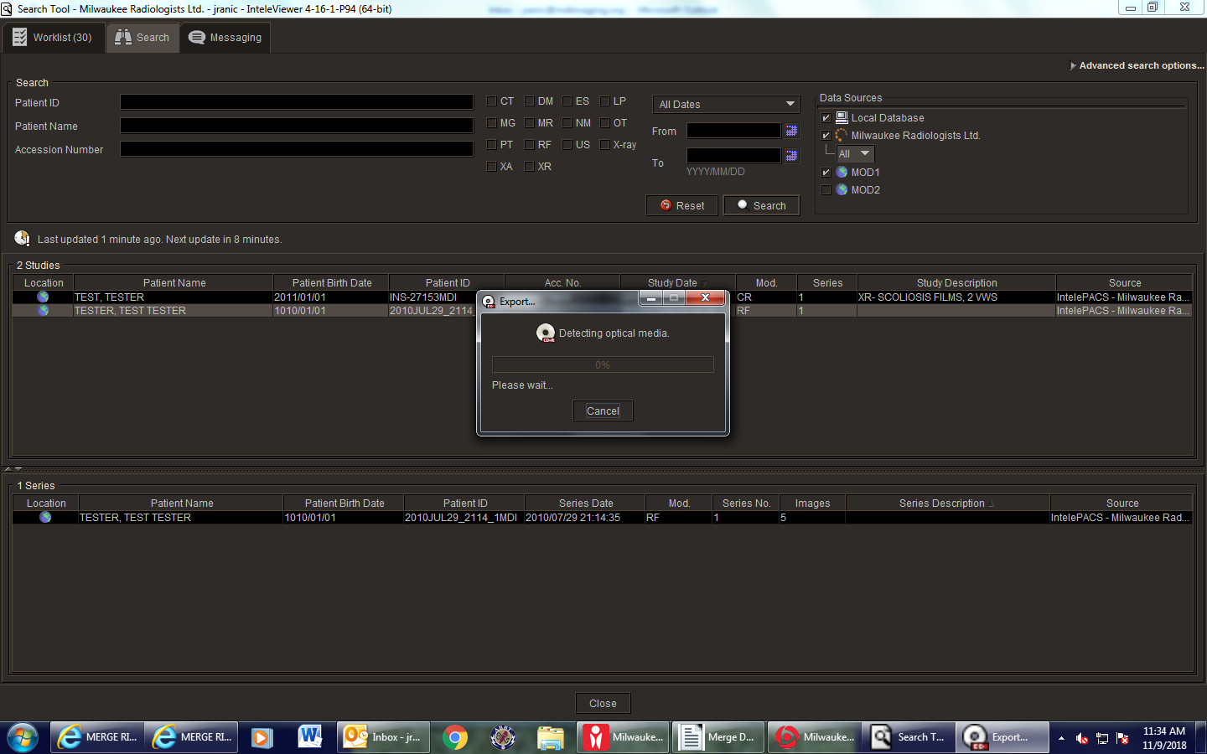
- Once the disc is done burning, the tray will eject the disc.

